Charts



Scatter Charts

Recommended Charts in Excel Line Charts

Bar Charts and Column Charts

A Note on Pie Charts and Three-Dimensional Charts

Bubble Charts Heat Maps

Additional Charts for Multiple Variables

PivotCharts in Excel

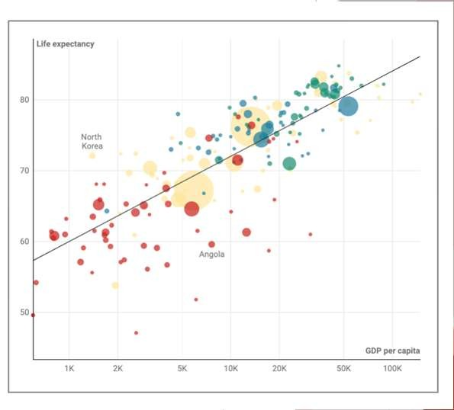

Charts

* **Charts** (or graphs): Visual methods of displaying data.
* **Scatter chart**:
  + Graphical presentation of the relationship between two quantitative variables.
* **Trendline**:
  + A line that provides an approximation of the relationship between the variables.

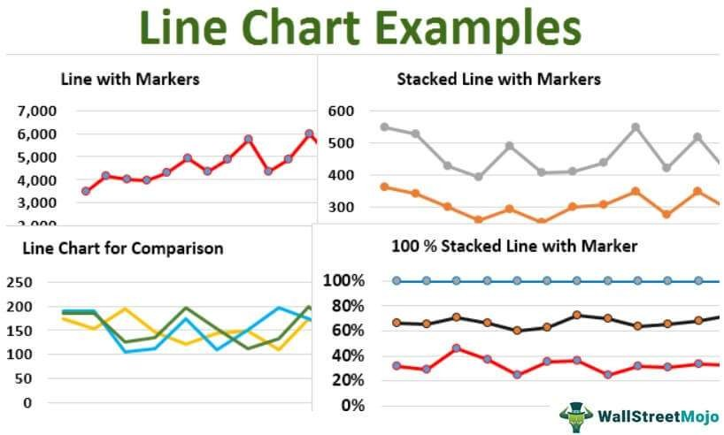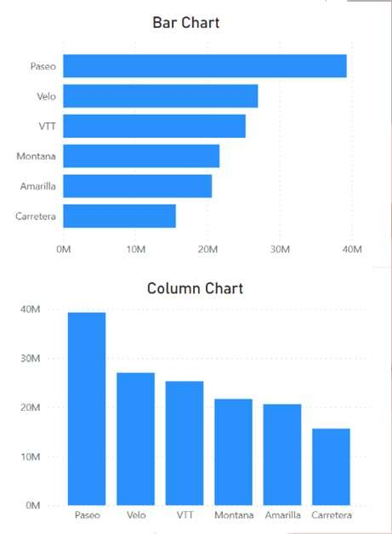

Charts

* **Line chart**: A line connects the points in the chart.
  + Useful for time series data collected over a period of time (minutes, hours, days, years, etc.).



Charts

* **Bar Charts**:
  + Use horizontal bars to display the magnitude of the quantitative variable.
* **Column Charts**:
  + Use vertical bars to display the magnitude of the quantitative variable.
* Bar and column charts are very helpful in making comparisons between categorical variables.

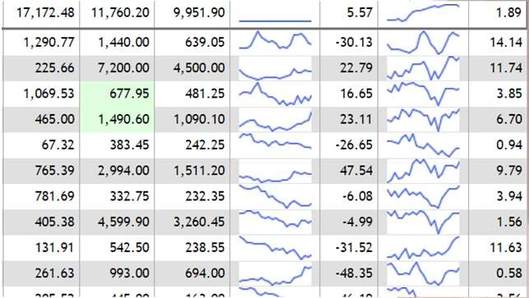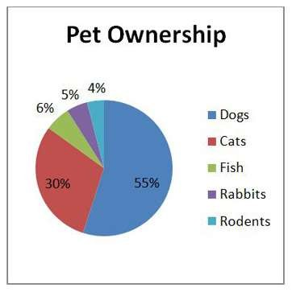

Charts

**Sparkline:** Special type of line chart:

* Minimalist type of line chart that can be placed directly into a cell in Excel.
* Contains no axes; they display only the line for the data.
* Takes up very little space and can be effectively used to provide information on overall trends for time series data.



Charts

* **Pie chart**:
  + Common form of chart used to compare categorical data.
  + Try to avoid 3-D pie charts
  + 3-D Charts:
    - Lower data-ink ratio
    - Make it harder to read sometimes
    - Not necessary when a 2-D graph will do

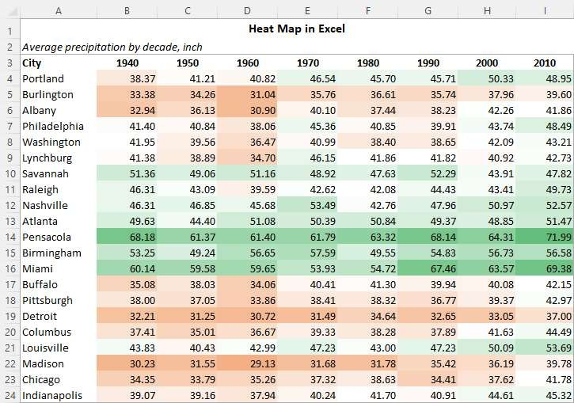

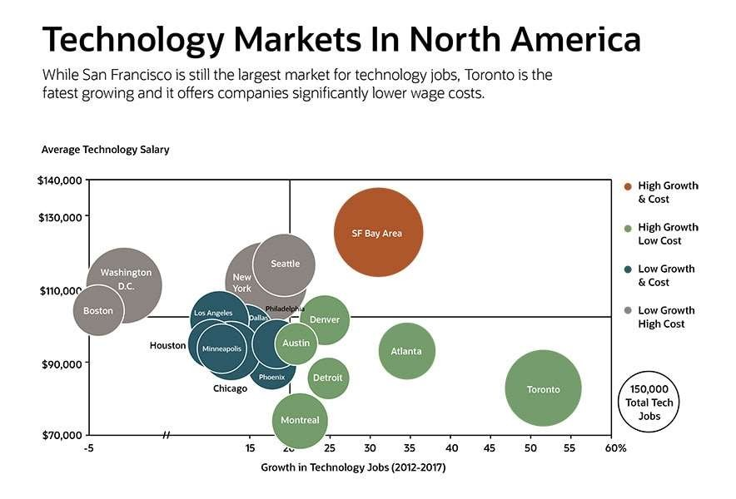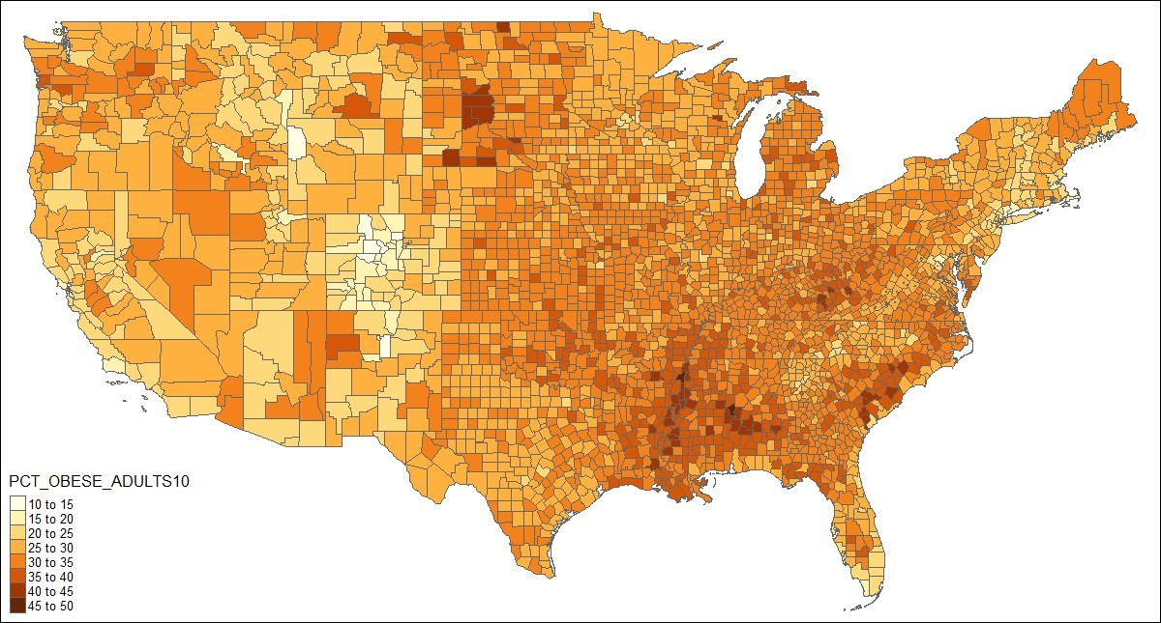

Charts

* **Bubble chart**:
  + Graphical means of visualizing three variables in a two- dimensional graph
  + Sometimes is a preferred alternative to a 3-D graph.



Charts

* **Heat map**:
  + A two-dimensional graphical representation of data
  + Uses different shades of color to indicate magnitude.

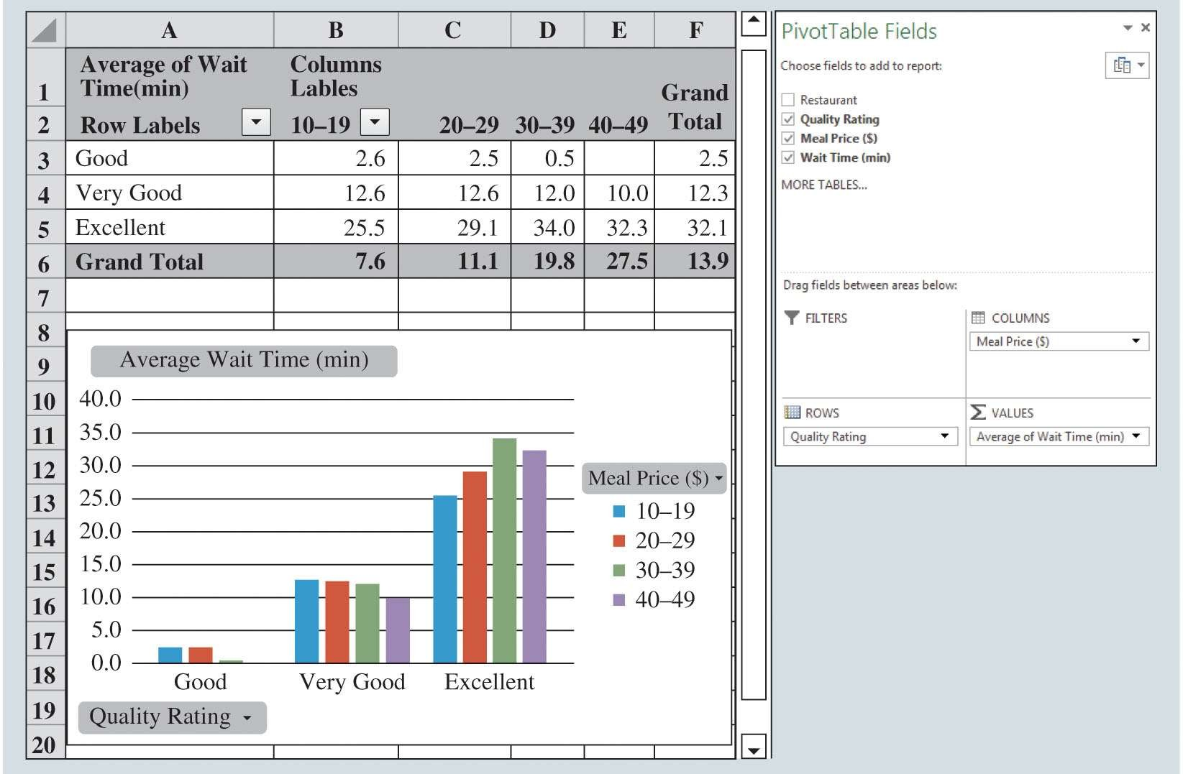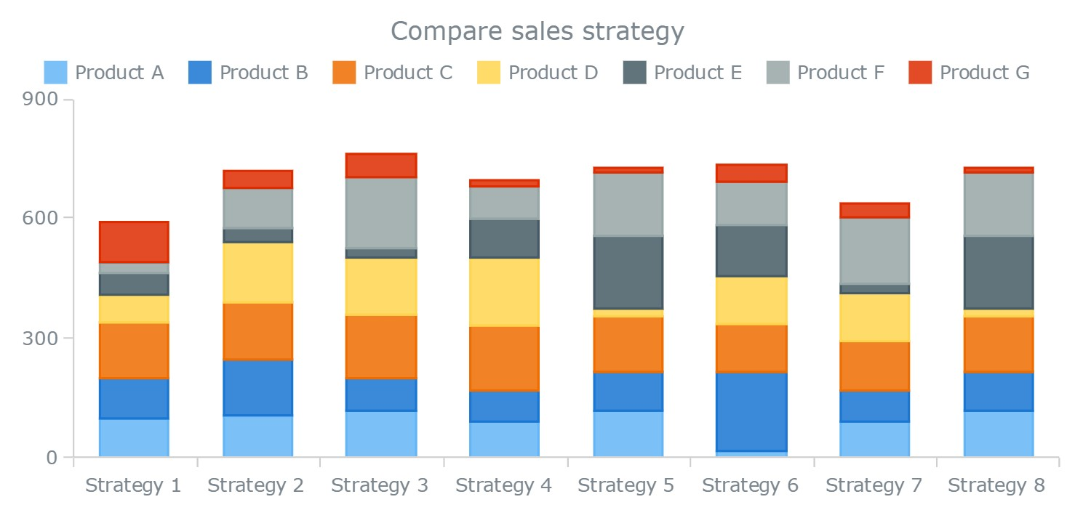

Charts

PivotCharts in Excel:

**PivotChart**:

* Summarize and analyze data with both a crosstabulation and charting
* Excel pairs PivotCharts with PivotTables.



Charts

Additional Charts for Multiple Variables:

* **Stacked-column chart**:
  + Allows the reader to compare the relative values of quantitative variables for the same category in a bar chart.
  + Sometimes other charts (i.e. clustered bar charts are preferred)
    - Clustered bar charts are typically easier to read

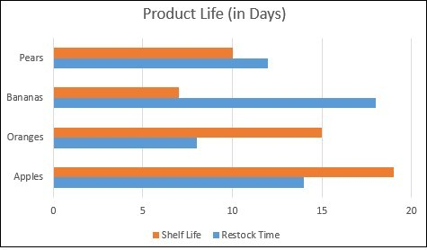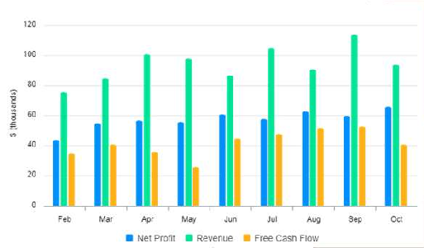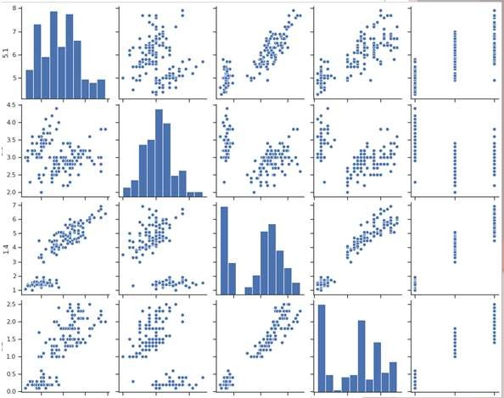

Charts

Additional Charts for Multiple Variables:

* **Clustered-column (or bar) chart**:
  + An alternative chart to stacked- column chart for comparing quantitative variables.
  + Do you think they are easier to read?



Charts

Additional Charts for Multiple Variables:

* **Scatter-chart matrix**:
  + Useful chart for displaying multiple variables.
  + Shows relationship between 2 variables on the peripheral
  + On the diagonal:
    - Histograms/distributions, or
    - Relationships between variables and themselves
* UNFORTUNATELY – Can’t make these in Excel.

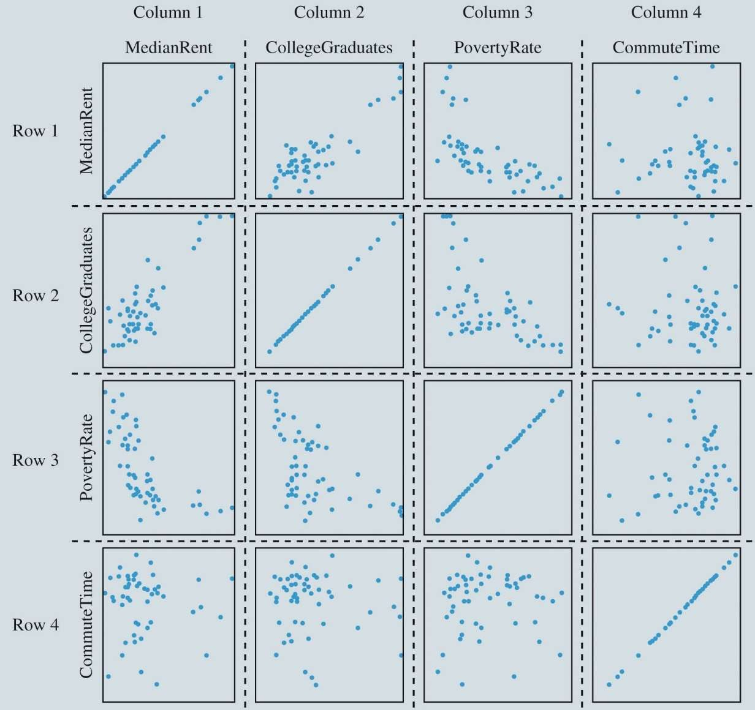

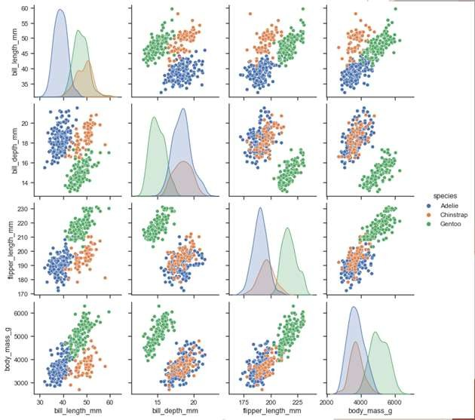

Charts in Excel

Table 3.8: Sample Data for the San Francisco Electronics Store



Scatter-Chart Matrix

|  |  |  |
| --- | --- | --- |
| **Week** | **No. of Commercials**  ***x*** | **Sales ($100s)**  ***y*** |
| 1 | 2 | 50 |
| 2 | 5 | 57 |
| 3 | 1 | 41 |
| 4 | 3 | 54 |
| 5 | 4 | 54 |
| 6 | 1 | 38 |
| 7 | 5 | 63 |
| 8 | 3 | 48 |
| 9 | 4 | 59 |
| 10 | 2 | 46 |



Charts

Figure 3.17: Scatter Chart for the San Francisco Electronics Store

Charts

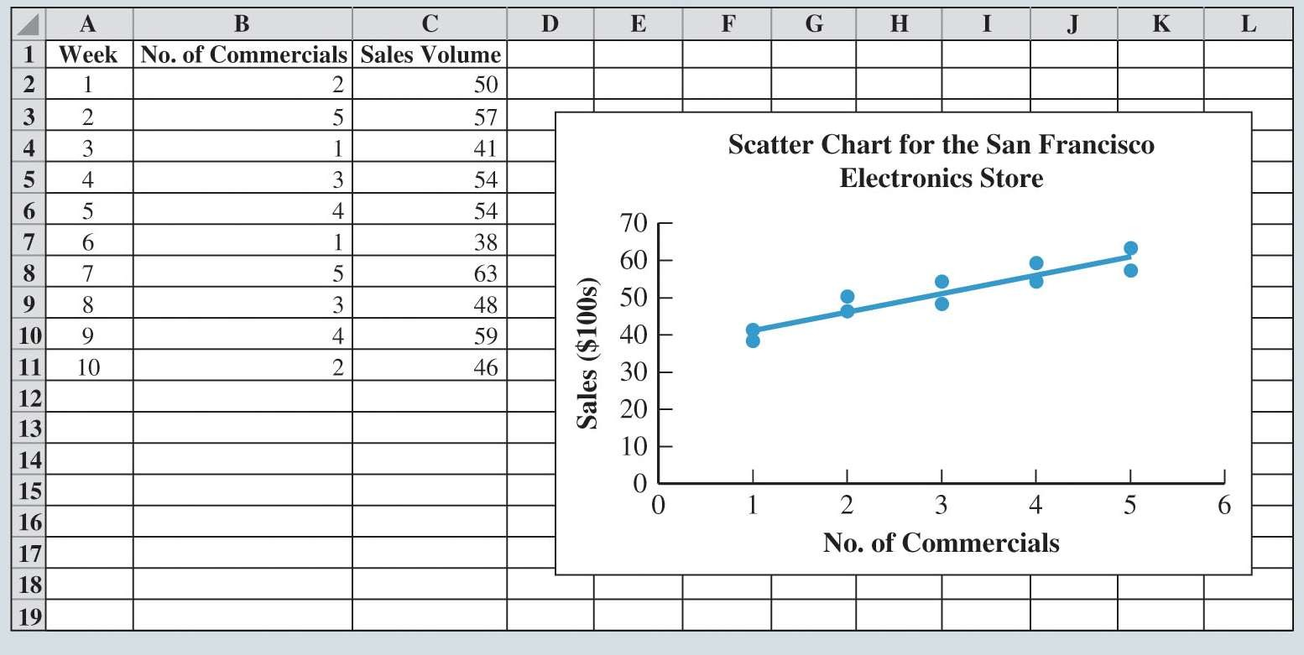

Table 3.9: Monthly Sales Data of Air Compressors at Kirkland Industries

**Month Sales ($100s)**

Jan 135

Feb 145

Mar 175

Apr 180

May 160

Jun 135

Jul 210

Aug 175

Sep 160

Oct 120

Nov 115

Dec 120

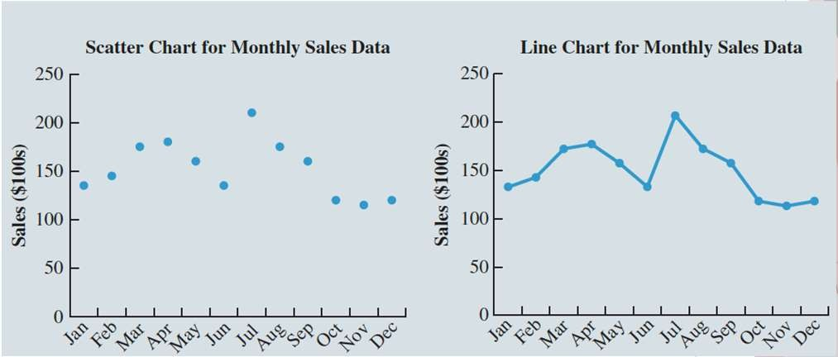

Charts

Table 3.10: Regional Sales Data by Month for Air Compressors at Kirkland Industries

**Month**

**Sales ($100s) North Sales ($100s) South**



Charts

Figure 3.19: Scatter Chart and Line Chart for Monthly Sales Data at Kirkland Industries

|  |  |  |
| --- | --- | --- |
| Jan | 95 | 40 |
| Feb | 100 | 45 |
| Mar | 120 | 55 |
| Apr | 115 | 65 |
| May | 100 | 60 |
| Jun | 85 | 50 |
| Jul | 135 | 75 |
| Aug | 110 | 65 |
| Sep | 100 | 60 |
| Oct | 50 | 70 |
| Nov | 40 | 75 |
| Dec | 40 | 80 |

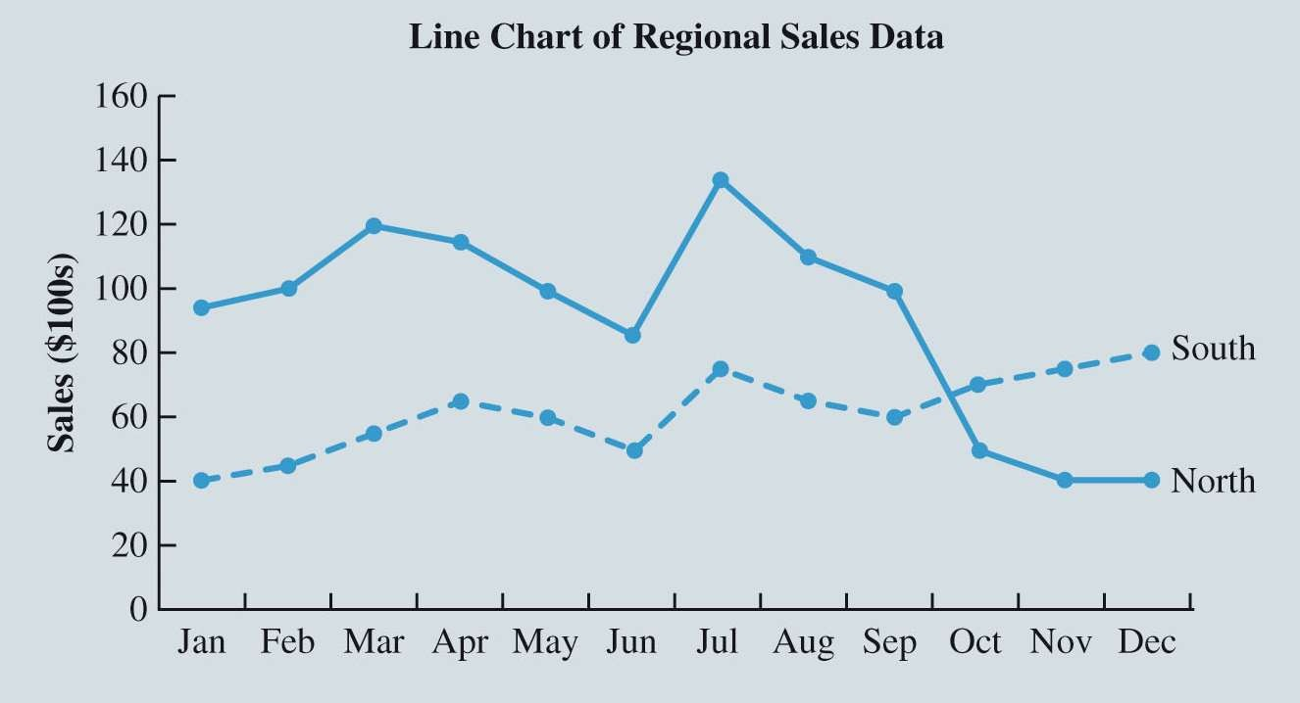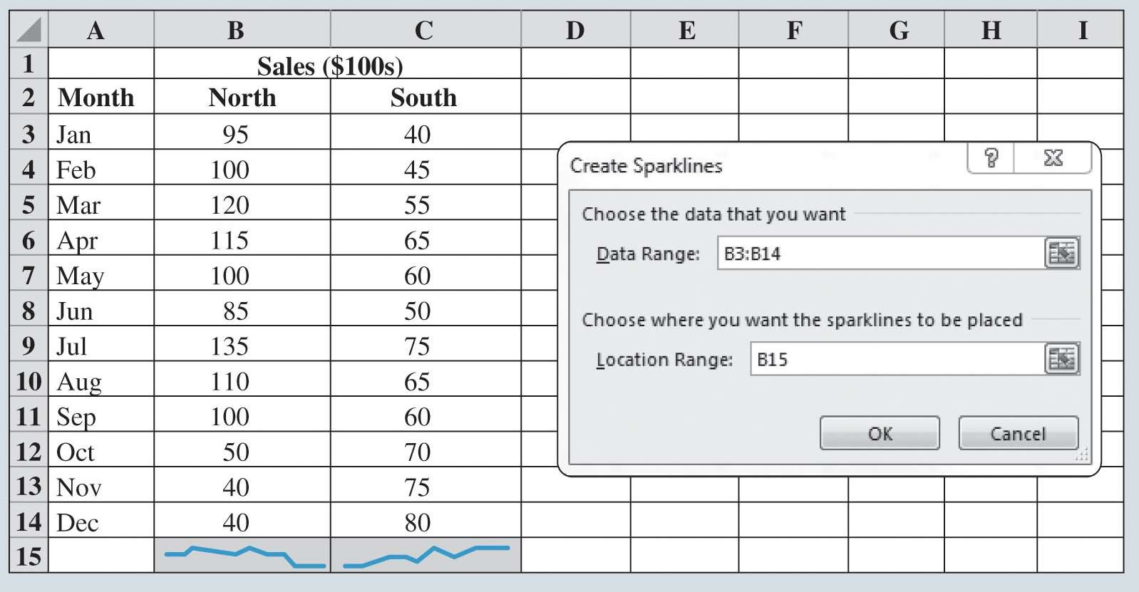

Charts

Figure 3.21: Line Chart of Regional Sales Data at Kirkland Industries



Charts

Figure 3.22: Sparklines for the Regional Sales Data at Kirkland Industries

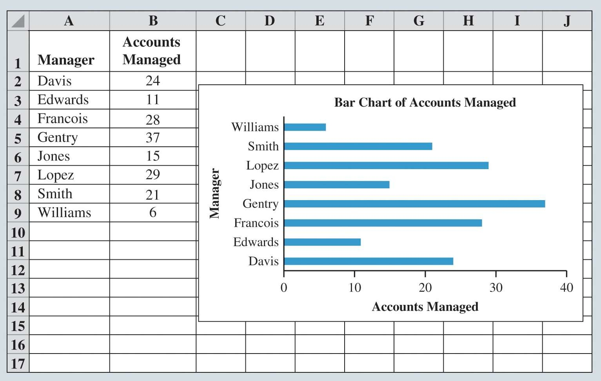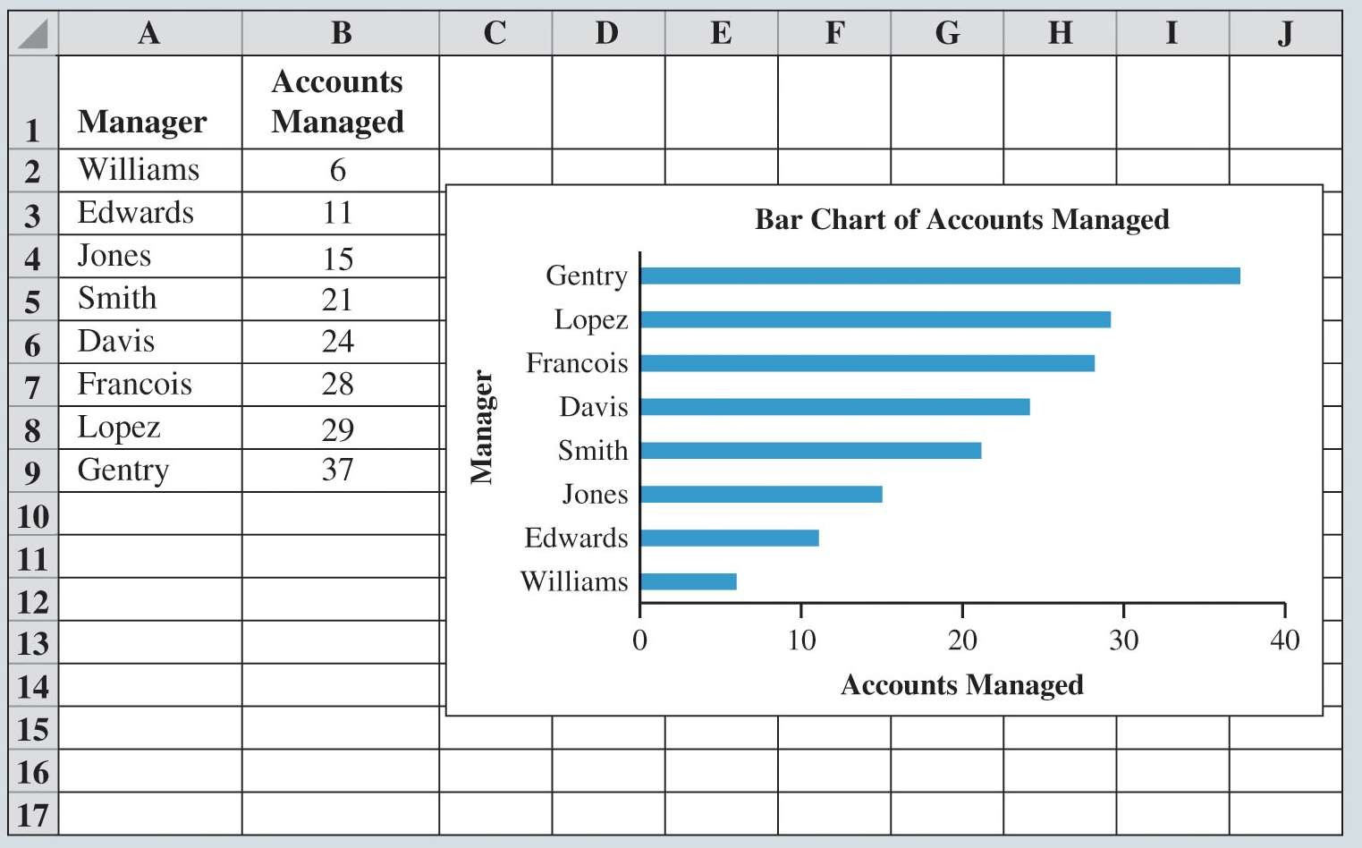

Charts

Figure 3.23: Bar Charts for Accounts Managed Data

Gentry manages the greatest number of accounts and Williams the fewest.



Charts

Figure 3.24: Sorted Bar Chart for Accounts Managed Data

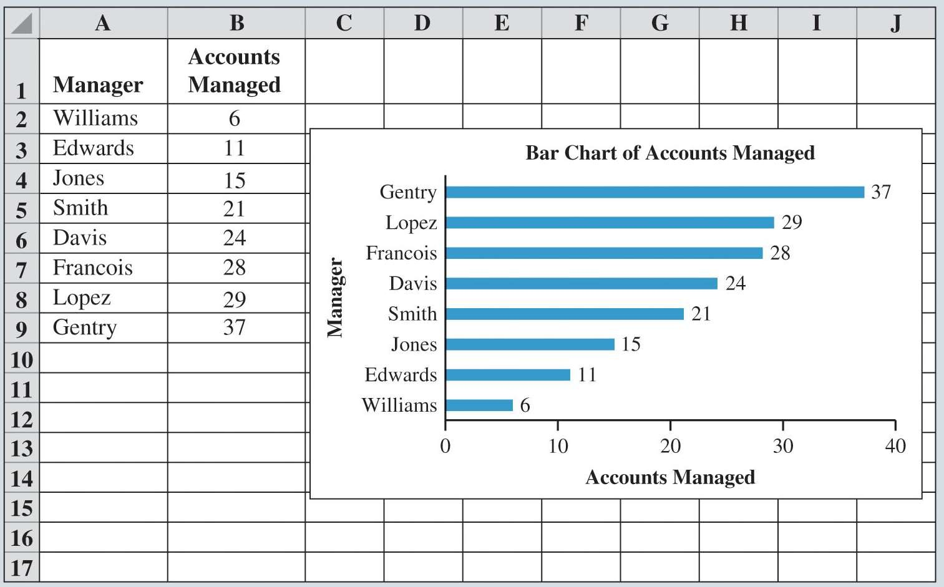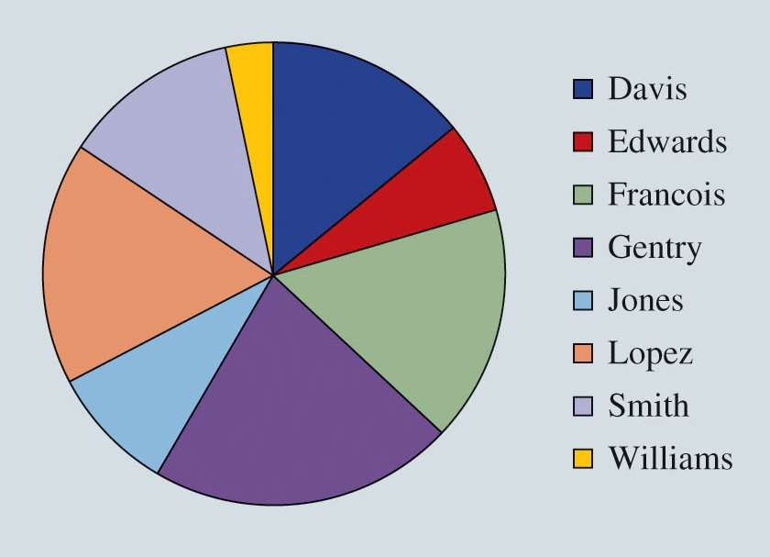

Charts

Figure 3.25: Bar Chart with Data Labels for Accounts Managed Data



Charts

Figure 3.26: Pie Chart of Accounts Managed



Charts

Table 3.11: Sample Data on Billionaires per Country

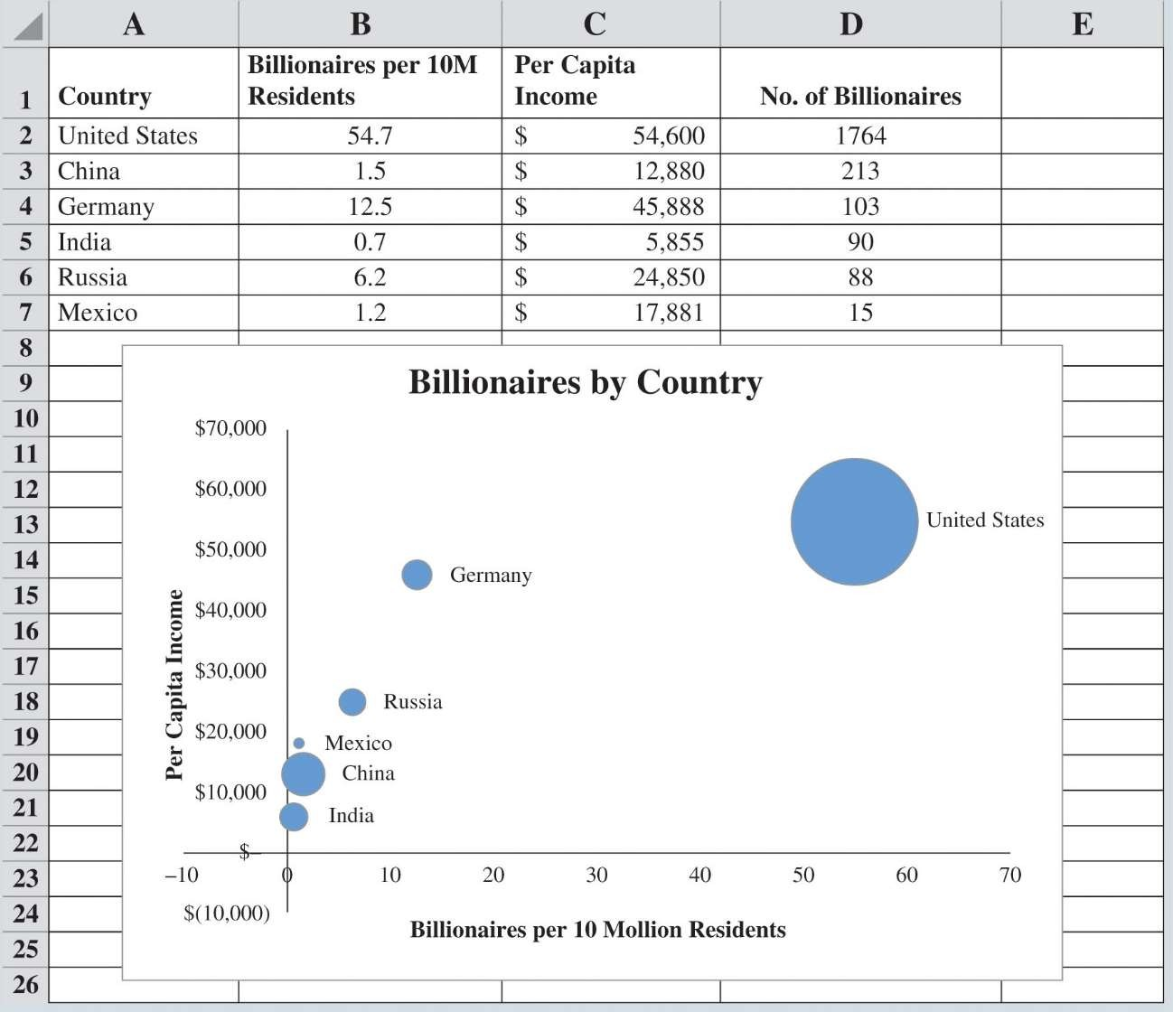

|  |  |  |  |
| --- | --- | --- | --- |
| **Country** | **Billionaires per 10M**  **Residents** | **Per Capita**  **Income** | **No. of**  **Billionaires** |
| United States | 54.7 | $54,600 | 1,764 |
| China | 1.5 | $12,880 | 213 |
| Germany | 12.5 | $45,888 | 103 |
| India | 0.7 | $ 5,855 | 90 |
| Russia | 6.2 | $24,850 | 88 |
| Mexico | 1.2 | $17,881 | 15 |



Charts

Figure 3.27: Bubble Chart Comparing Billionaires by Country

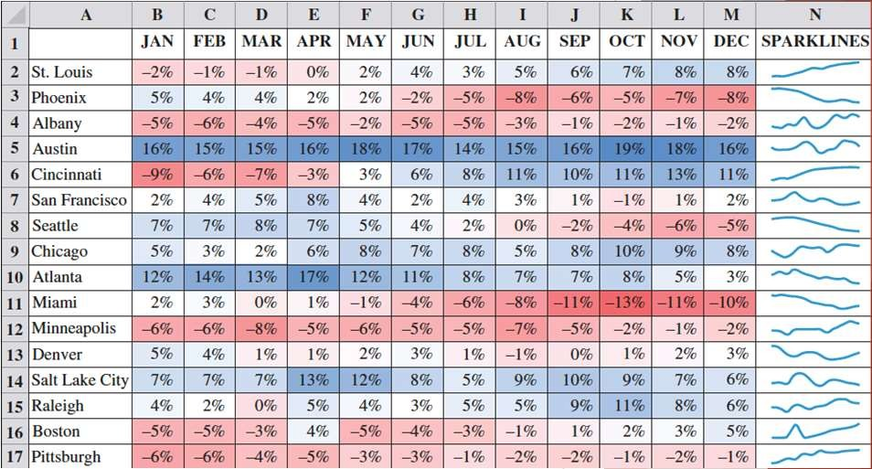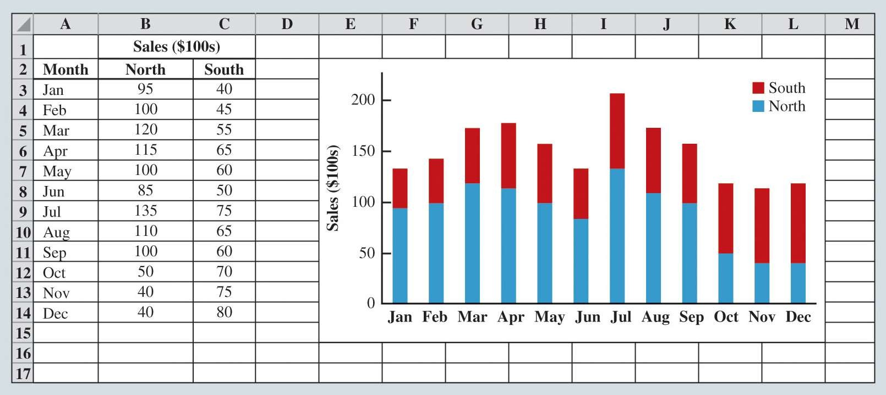

Charts

Figure 3.28: Heat Map and Sparklines for Same-Store Sales Data



Charts

Figure 3.29: Stacked-Column Chart for Regional Sales Data for Kirkland Industries

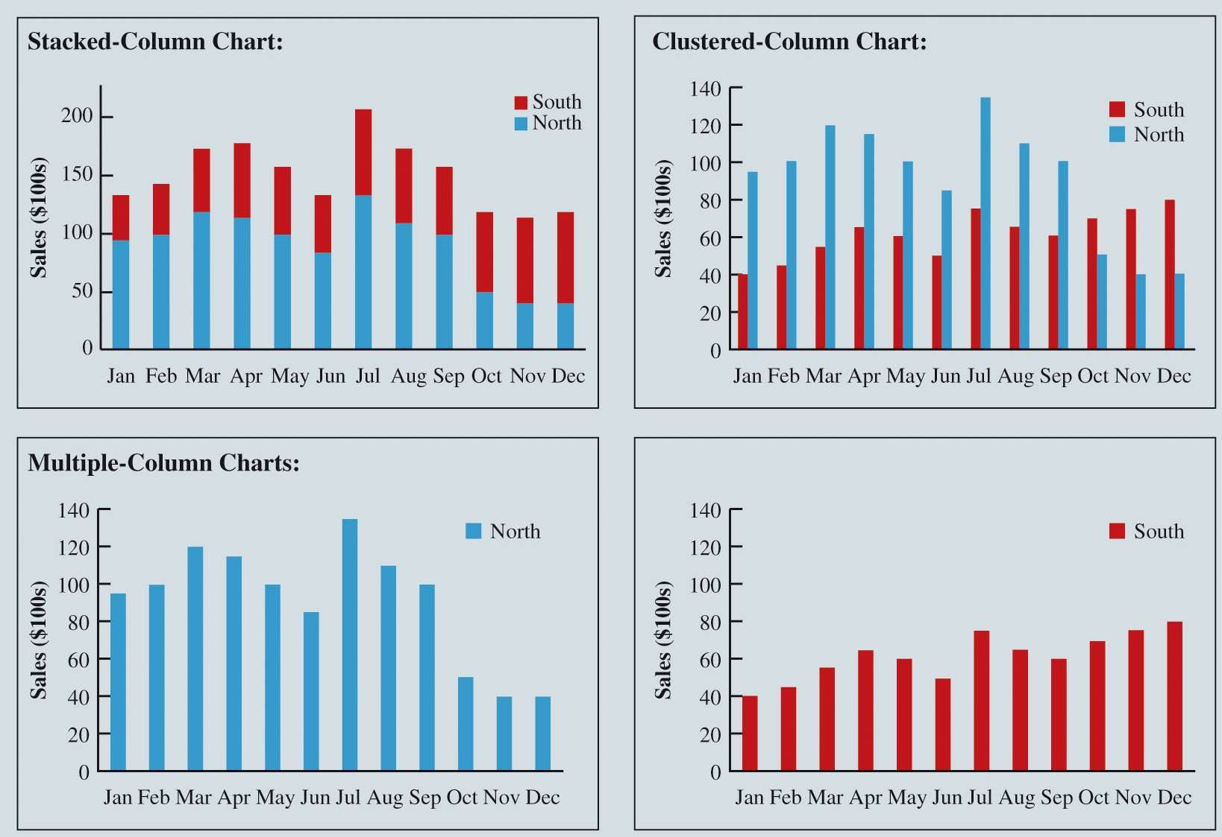

Charts

Table 3.12: Data for New York City Sub-boroughs



Charts

Figure 3.30: Comparing Stacked-, Clustered-, and Multiple-Column Charts for the Regional Sales Data for Kirkland Industries

|  |  |  |  |  |
| --- | --- | --- | --- | --- |
|  | **Median Monthly** | **Percentage**  **College** | **Poverty Rate** | **Travel Time** |
| **Area** | **Rent ($)** | **Graduates (%)** | **(%)** | **(min)** |
| Astoria | 1,106 | 36.8 | 15.9 | 35.4 |
| Bay Ridge | 1,082 | 34.3 | 15.6 | 41.9 |
| Bayside/Little Neck | 1,243 | 41.3 | 7.6 | 40.6 |
| Bedford Stuyvesant | 822 | 21.0 | 34.2 | 40.5 |
| Bensonhurst | 876 | 17.7 | 14.4 | 44.0 |
| Borough Park | 980 | 26.0 | 27.6 | 35.3 |



Charts

Table 3.12: Data for New York City Sub-boroughs (cont.)



|  |  |  |  |  |
| --- | --- | --- | --- | --- |
|  | **Median Monthly** | **Percentage**  **College** | **Poverty Rate** | **Travel Time** |
| **Area**  Brooklyn Heights/Fort | **Rent ($)** | **Graduates (%)** | **(%)** | **(min)** |
| Greene | 1,086 | 55.3 | 17.4 | 34.5 |
| Brownsville/Ocean Hill | 714 | 11.6 | 36.0 | 40.3 |
| Bushwick | 945 | 13.3 | 33.5 | 35.5 |
| Central Harlem | 665 | 30.6 | 27.1 | 25.0 |
| Chelsea/Clinton/Midtown | 1,624 | 66.1 | 12.7 | 43.7 |
| Coney Island | 786 | 27.2 | 20.0 | 46.3 |



Charts

Figure 3.31: Scatter-Chart Matrix for New York City Rent Data



Charts

Figure 3.32: PivotTable and PivotChart for the Restaurant Data